GUI Data Workshop

Worksheet 4a - Family Structure –
Child Cohort - Wave 1 (at 9 years), Wave 2 (at 13 years) and Wave 3 (at 17 years)

This document provides worked examples of some very basic commands which can be used to explore and analyse the GUI data using SPSS drop-down menus. It includes detailed screen shots of how the run the analysis using SPPS menus.
This worksheet is based on the matched Wave 1 (at 9 years), Wave 2 (at 13 years) and Wave 3 (at 17 years) files – please see accompanying information sheets for details on how to match the files.
Please note this worksheet is based on SPSS Version 24.
This example uses Convention A naming – and drop down menus. Examples of SPSS syntax will also be given.
Exercise 1: Cross-sectional - Family Structure at Wave 1 (at 9 years)
- First you will need to weight the data. Select Data → Weight Cases
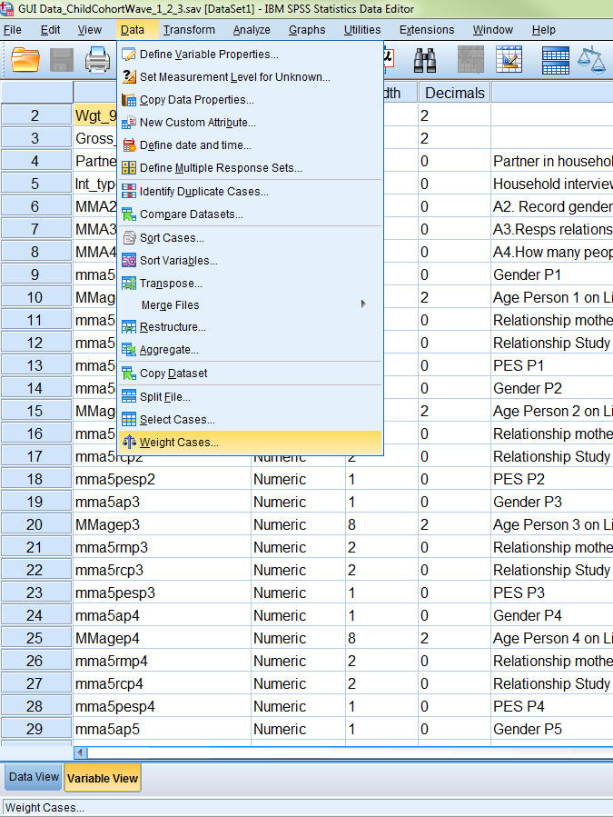

- The following dialog box will appear.
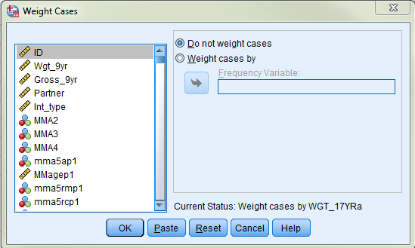

- Click on ‘Weight cases by’. Browse through the list of variables on the left and highlight the one you want (‘WGT_9YR’) and click on the arrow in the middle. Click on ‘OK’. Note that this is a cross-sectional analysis of the 8,568 cases in Wave 1 so we use the Wave 1 weight.

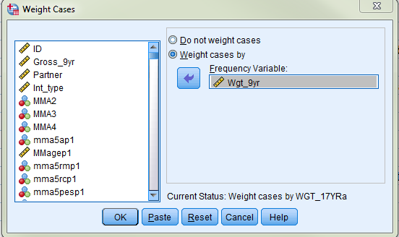

4. To run the frequency, select Analyse → Descriptive Statistics → Frequencies
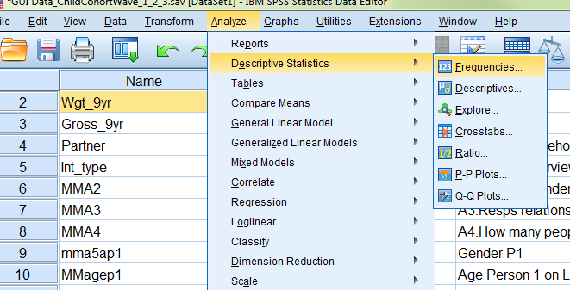
5. The following dialog box will appear:
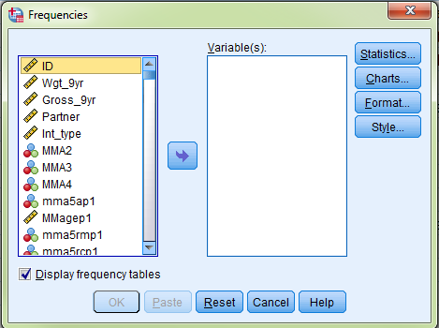

6. Browse through the list of variables on the left and highlight the one(s) you want (‘partner’ – partner in household) and click on the arrow in the middle.

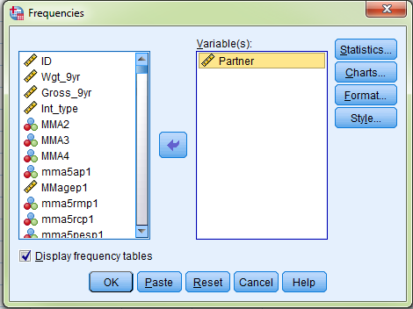

7. Click ‘OK’ and the output will show you the frequency table for that variable.

Partner Partner in household
 |  | Frequency | Percent | Valid Percent | Cumulative Percent
Valid | 0 No partner | 1554 | 18.1 | 18.1 | 18.1
Valid | 1 Has partner | 7014 | 81.9 | 81.9 | 100.0
Valid | Total | 8568 | 100.0 | 100.0

Exercise 2: Cross-sectional - Family Structure at Wave 2 (at 13 years)

First you will need to weight the data, using the Wave 2 weight this time.
1. Data → Weight Cases → WGT_13YR
2. Analyse → Descriptive Statistics → Frequencies → W2partner
A weighted frequency of this will give us the following output:

w2partner Partner in household - Wave 2
 |  | Frequency | Percent | Valid Percent | Cumulative Percent
Valid | .00 No partner in household | 1450 | 19.3 | 19.3 | 19.3
Valid | 1.00 Partner in household | 6075 | 80.7 | 80.7 | 100.0
Valid | Total | 7525 | 100.0 | 100.0

Note that although this frequency is run on the full matched file of 8568 cases, results are only shown for the 7525 Wave 2 cases. You will see the following warning in the output window which refers to this (if you have set SPSS to display a log. To do this, click Edit → Options → Viewer → Item → Log → Contents are initially Shown):

>Warning # 3211
On at least one case, the value of the weight variable was zero, negative, or missing. Such cases are invisible to statistical procedures and graphs which need positively weighted cases, but remain on the file and are processed by non-statistical facilities such as LIST and SAVE.

Exercise 3: Cross-sectional - Family Structure at Wave 3 (at 17 years)

First you will need to weight the data, using the Wave 3 weight this time. Note we want to analyse all 6,216 families that participated in Wave 3 (not the subset that participated at all three waves) so we use ‘WGT_17Yra’. See accompanying Information Sheets for more information on the weights at Wave 3.

1. Data → Weight Cases → WGT_17YRa

2. Analyse → Descriptive Statistics → Frequencies → W3partner
A weighted frequency of this will give us the following output:

w3partner Partner in household - Wave 3
 |  | Frequency | Percent | Valid Percent | Cumulative Percent
Valid | .00 No partner in household | 1257 | 20.2 | 20.5 | 20.5
Valid | 1.00 Partner in household | 4866 | 78.3 | 79.5 | 100.0
Valid | Total | 6123 | 98.5 | 100.0
Missing | System | 93 | 1.5
Total |  | 6216 | 100.0

Exercise 4: Changes in Family Structure across Waves
The cross-sectional analyses above show the proportions of children in one and two-parent households for each wave. The results are summarized in Figure 1 below. A total of 18.1% of 9 year olds were in one parent households, 19.3% of 13 year old children were in one parent households and 20.2% of 17 year old children were in one parent households.

Figure 1: Family Structure at each wave
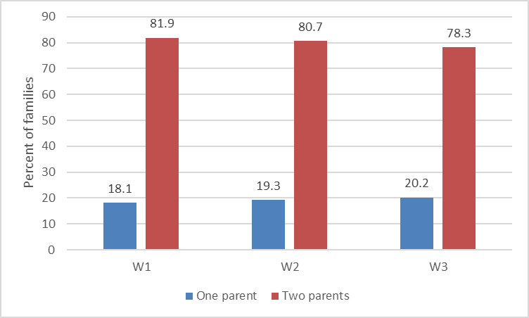

From these cross-sectional analyses it appears that family structure is reasonably stable across waves with similar proportions of children in one parent households at each wave. However, these are separate analyses and do not tell us anything about changes in family structure from wave to wave.

To look at changes in family structure between Wave 1 and Wave 3, we need to do a crosstabulation of the two variables in each wave. In order to do this, we will be analysing only the 6,123 cases who responded in both Wave 1 and Wave 3, and using the Wave 3 a weight (‘WGT_17Yra’). The Wave 3 a weight adjusts the data to make it representative of all children who were resident in Ireland at Wave 1 and who continue to be resident in Ireland at Wave 3 (accounting for those who no longer live in Ireland at 17 years of age or who have deceased since 9 years of age).
1. Data → Weight Cases → WGT_17YRa
2. Analyse → Descriptive Statistics → Crosstabs
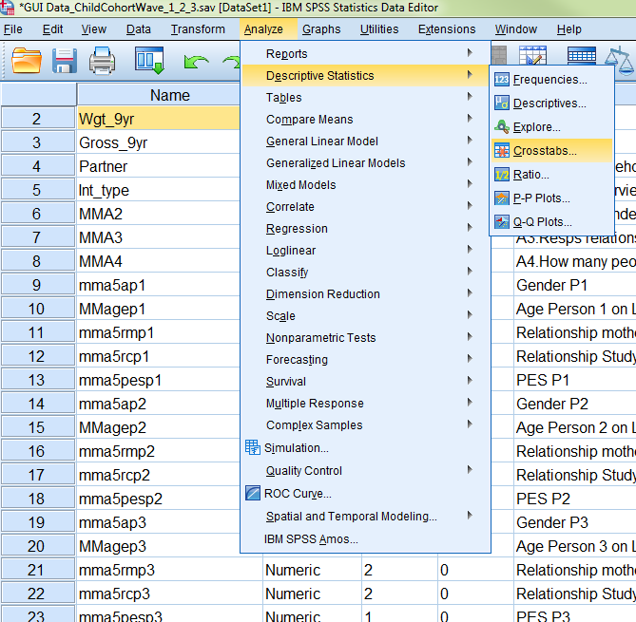

3. The following dialog box will appear.
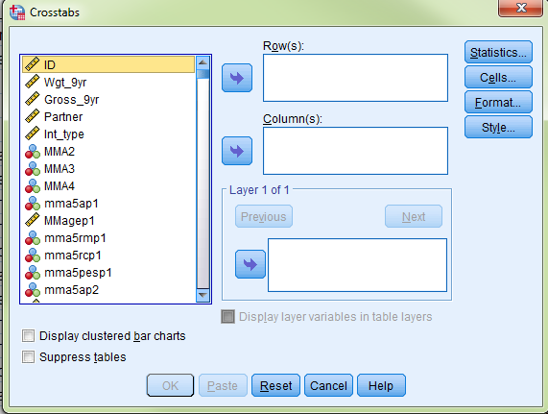
4. Browse and highlight the variables you want to cross-reference and move them to the row and column boxes as applicable. Move ‘partner’ to the ‘Rows’ box and ‘W3partner’ to the ‘Columns’ box.
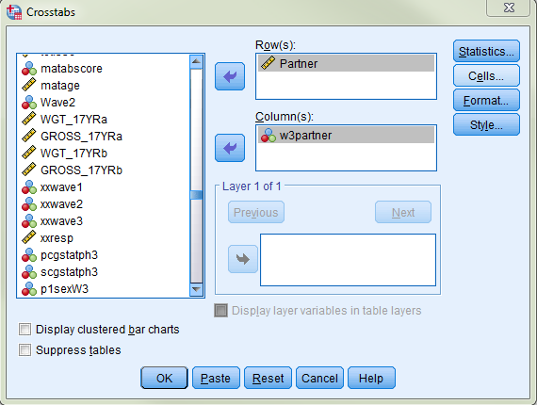
5. Select ‘Cells’ and the following dialog box will appear
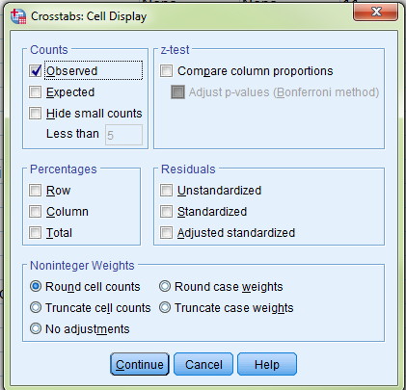
6. Under ‘Percentages’, click “Row” and “Total”

7. Click ‘Continue’ and then ‘OK’ and you will get the following output:
Partner Partner in household * w3partner Partner in household - Wave 3 Crosstabulation
 |  |  | w3partner Partner in household - Wave 3 |  | Total
 |  |  | .00 No partner in household | 1.00 Partner in household | Total
Partner Partner in household | 0 No partner | Count | A. 811 | 248 | 1059
Partner Partner in household | 0 No partner | % within Partner Partner in household | 76.6% | B. 23.4% | 100.0%
Partner Partner in household | 0 No partner | % of Total | 13.2% | C. 4.1% | 17.3%
Partner Partner in household | 1 Has partner | Count | 446 | 4618 | 5064
Partner Partner in household | 1 Has partner | % within Partner Partner in household | 8.8% | 91.2% | 100.0%
Partner Partner in household | 1 Has partner | % of Total | 7.3% | 75.4% | 82.7%
Total |  | Count | 1257 | 4866 | 6123
 |  | % within Partner Partner in household | 20.5% | 79.5% | 100.0%
 |  | % of Total | 20.5% | 79.5% | 100.0%

Note:
- The first row of information shows the number of children in each of the cells. For e.g. 811 children were in one parent households at Wave 1 and also at Wave 3
- The second row of information shows the percentage of children in each one parent household status category at Wave 1 who are in each of the Wave 3 one parent household status categories. For e.g. 23.4% of children who were in one parent households at Wave 1 were in two parent households at Wave 3.
- The third row of information shows the percentage of all children in each of the cells. For e.g. the category of children who were in one parent households at Wave 1 and were in two parent households at Wave 3 accounts for 4.1% of all children.
8. A new variable can be created to classify children according to their status with regards to changes in family structure between Wave 1 and Wave 3. The easiest way to do this is using SPSS syntax and the code to do so is displayed below.

SPSS syntax computing family structure
COMPUTE famstructure = sysmis.
IF partner = 0 and w3partner = 0 famstructure = 1.
IF partner = 0 and w3partner = 1 famstructure = 2.
IF partner = 1 and w3partner = 0 famstructure = 3.
IF partner = 1 and w3partner = 1 famstructure = 4.

VARIABLE LABELS famstructure "Changes in family structure from Wave 1 to Wave 3".

VALUE LABELS famstructure
1 "One-parent at 9 yrs / One-parent at 17 yrs"
2 "One-parent at 9 yrs / Two-parent at 17 yrs"
3 "Two-parent at 9 yrs / One-parent at 17 yrs"
4 "Two-parent at 9 yrs s / Two-parent at 17 yrs".

FREQUENCIES famstructure.

These changes in family structure from Wave 1 to Wave 3 are summarized in Figure 2 below. Although the previous cross-sectional results shown in Figure 1 above suggest that there is little variation in family structure across waves, the longitudinal results in Figure 2 show that 4.1% of children who were in one parent households at Wave 1 were in two parent households at Wave 3 and 7.3% of those in two-parent households at Wave 1 were in one-parent households at Wave 3.
These changes in family structure may be an important consideration when looking at outcomes at Wave 3.
Figure 2: Changes in Family Structure from Wave 1 to Wave 3
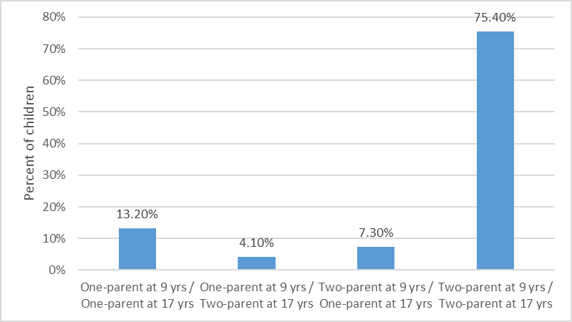

9. As just one example of how children’s outcomes may vary according to changes in family structure across waves we can look at the mean SDQ Total Difficulties score at 17 years across each of the four categories of family structure.

10. Analyze → Compare Means → Means
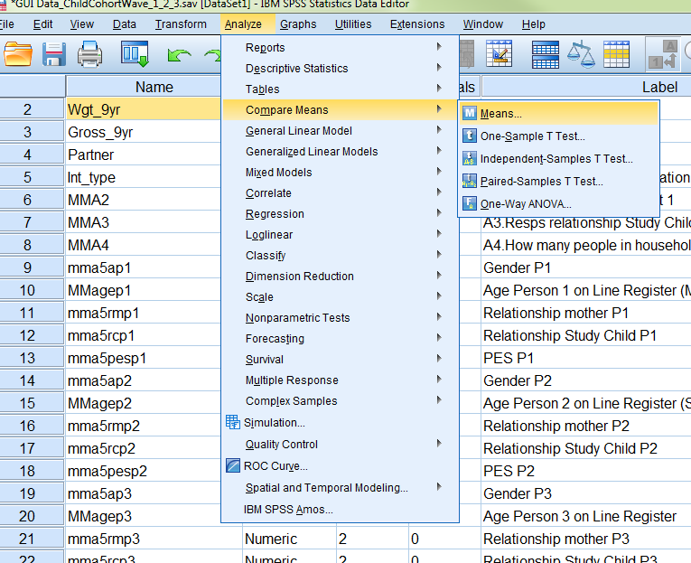
11. A dialogue box will open. Move the variable ‘w3pcg_SDQtotaldiffs’ into the Dependent List box and move ‘famstructure’ into the Independent List box. Click ‘ok’.
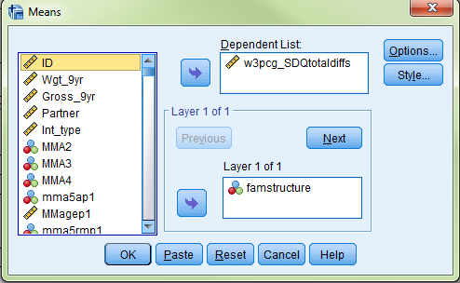

12. This will give the following results.

Report
w3pcg_SDQtotaldiffs SDQ Total difficulties score - PCG Wave 3
famstructure Changes in family structure from Wave 1 to Wave 3 | Mean | N | Std. Deviation
1.00 One-parent at 9 yrs / One-parent at 17 yrs | 8.5493 | 811 | 5.50900
2.00 One-parent at 9 yrs / Two-parent at 17 yrs | 7.6080 | 248 | 4.71917
3.00 Two-parent at 9 yrs / One-parent at 17 yrs | 8.5055 | 446 | 5.82783
4.00 Two-parent at 9 yrs / Two-parent at 17 yrs | 6.4414 | 4616 | 4.86320
Total | 6.9181 | 6121 | 5.09368

These results are summarized in Figure 3 below which shows the mean SDQ Total Difficulties score of 17 year old children across the four categories of changes in family structure between Wave 1 and Wave 3. We can see from this that the lowest scores (fewest problems) are experienced by children in “stable” two parent families (two parent at Wave 1 and Wave 3).

The highest scores (most problems) are experienced by those who either remain a one parent family across 3 waves, or those who change from a two Parent family at Wave 1 to a two parent family at Wave 3. Obviously, more investigation is needed into this before conclusions could be made but it nicely demonstrates the value of using longitudinal data to examine children’s outcomes.

Figure 3: SDQ Total Difficulties score by changes in family structure from Wave 1 to Wave 3
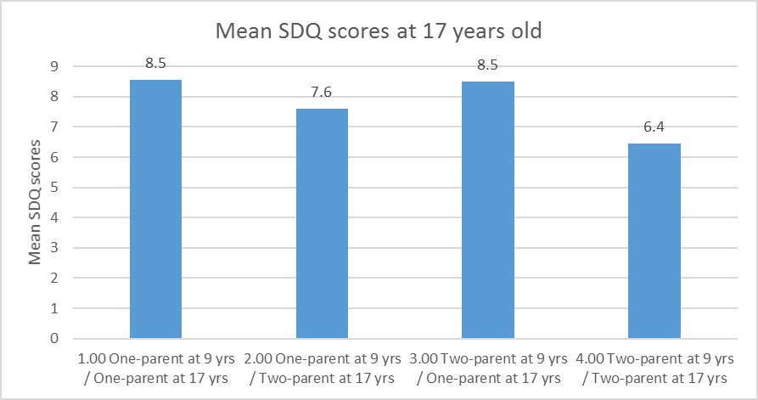
All operations can be summarized very succinctly using SPSS syntax.
Summary using SPSS syntax
WEIGHT by WGT_9yr.
FREQUENCIES partner.

WEIGHT by WGT_13yr.
FREQUENCIES w2partner.

WEIGHT by WGT_17yra.
FREQUENCIES w3partner.

WEIGHT by WGT_17yra.
CROSSTABS TABLES partner by w3partner / CELLS count row total.

COMPUTE famstructure = sysmis.
IF partner = 0 and w3partner = 0 famstructure = 1.
IF partner = 0 and w3partner = 1 famstructure = 2.
IF partner = 1 and w3partner = 0 famstructure = 3.
IF partner = 1 and w3partner = 1 famstructure = 4.
VARIABLE LABELS famstructure "Changes in family structure from Wave 1 to Wave 3".

VALUE LABELS famstructure
1 "One-parent at 9 yrs / One-parent at 17 yrs"
2 "One-parent at 9 yrs / Two-parent at 17 yrs"
3 "Two-parent at 9 yrs / One-parent at 17 yrs"
4 "Two-parent at 9 yrs / Two-parent at 17 yrs".

FREQUENCIES famstructure.

MEANS TABLES w3pcg_SDQtotaldiffs by famstructure.

? See Variable Naming Conventions And Longitudinal Data Dictionary For Wave 1 And Wave 2 Of The Child Cohort Of Growing Up In Ireland document for further details on variable naming conventions.

